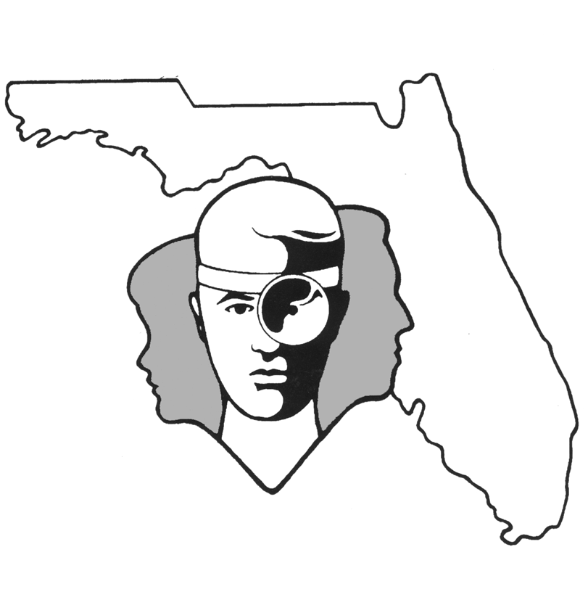
TALLAHASSEE EAR, NOSE & THROAT - HEAD & NECK SURGERY, P.A.

www.TallyENT.com Phone: (850) 877-0101

UVULOPALATOPHARYNGOPLASTY (UPPP or UP3)

Your physician has proposed a uvulopalatopharyngoplasty (UPPP) for treatment of your obstructive sleep apnea. Obstructive sleep apnea is sometimes associated with an overly long and thick soft palate or elongated or widened uvula. The removal of this excessive tissue for the treatment of sleep apnea is termed an uvulopalatopharyngoplasty or UPPP. The tonsils, which sit on either side of the throat just below the palate, are also frequently involved in the formation of a narrowed airway and subsequent sleep apnea. When present, they are generally removed along with the trimming of the palate and uvula in performing a UPPP with tonsillectomy.

Obstructive sleep apnea is a long-term health risk which is frequently associated with severe snoring, long pauses in breathing during sleeping, struggling to breathe, and general symptoms of sleep deprivation, such as daytime fatigue and an inability to concentrate. Other long-term health effects include an increased risk of high blood pressure, heart attack, stroke, and early death. Because of the severe symptomatic complaints and potential long-term health risks, the treatment of sleep apnea is very important to one’s health. Generally, there are several forms of treatment of apnea, including weight loss, surgical correction of any anatomic deformities, or the use of CPAP. Your surgeon, at this time, feels like surgical intervention (UPPP) would be helpful in your particular situation.

UPPP can be a successful surgery for patients - if they are chosen carefully. In general, success rates are higher for patients with large tonsils, an elongated uvula and elongated soft palate. The success rate decreases for patients who have a narrow throat or pharynx or do not have large tongues. Patients with mild to moderate sleep apnea tend to have better success rates. Overall, obesity decreases the success rate for this procedure. For patients with favorable anatomy or mild to moderate sleep apnea, success rates for this type of surgery ranges from 55-85%, but successful surgery is typically defined as a significant reduction in the Respiratory Disturbance Index (RDI). This can be determined if the postoperative sleep study has an RDI of less than 20 (< 5 is considered normal). This means that some patients may have successful surgery, but still technically have sleep apnea. Depending on the severity of the sleep apnea after surgery, some patients may still need to use CPAP or consider additional surgery. These are all factors which your surgeon has considered in recommending the UPPP, either with or without tonsillectomy, to you at this time. Additional factors which have been considered would be your overall health and any underlying factors which might preclude you from using the nasal CPAP, such as claustrophobia, nasal obstruction, or the inability to wear the mask for anatomic reasons.

The UPPP is generally performed using electrocautery. This leads to very little blood loss during the procedure. The major risk of a UPPP is blood loss, especially when tonsils are removed in conjunction with the trimming of the palate. The overall risk of this occurring is around two to three percent. The major time frames where this is most likely to occur are within the first 24 hours of surgery and at around one week postoperatively. Because of this risk of bleeding, we do request that patients refrain from using any aspirin-containing products for 10 days prior to surgery and from using any ibuprofen or similar medications for three days prior to surgery. These products should also not be taken for two weeks after surgery. Acceptable pain medicines include Tylenol or the prescription pain medicine given to you by your physician postoperatively.

Additional risks associated with a UPPP include removing so much of the soft palate that it is unable to close against the back wall of the throat during swallowing or talking. This potentially leads to a somewhat “airy” sounding voice and also to potential problems with foods, and, in particular, liquids coming out of the nose while eating. The risk of this problem is around 10-20%. Usually this is a self-limited problem which gets better within a six-week period postoperatively. It is rarely an ongoing problem in patients, but this occurs less than one percent of the time. Because the palate is shorter, some patients also note that it feels “different” when they swallow, even though they do not have actual food regurgitation.

There is also a small chance of scarring in the surgical site, which would potentially narrow the opening going up into the nose. This could lead to a slight decreased resonance of sound through the nose with talking and potential decreased ability to breathe easily through the nose. This complication is a difficult problem to correct but, fortunately, it is an extremely rare event.

One other thing that should be mentioned, not necessarily as a complication but more of an expectation, is that your throat will be extremely sore following this particular surgery especially if the tonsils are removed. In general, patients have a severe sore throat for the first week, a moderate sore throat for the second week, and mild sore throat for the third week postoperatively. We will certainly give you medications to try to help you through this, but you should mentally prepare yourself for this event since it is a rough gauge of how most patients fare postoperatively.

Because of the pain with swallowing, it may be difficult for some patients to drink enough liquids in the immediate postoperative period. If your surgeon feels that your liquid intake is inadequate, he/she may keep you in the hospital for 1-2 days to prevent dehydration. Additional reasons that your surgeon may wish to keep you overnight for observation include: underlying medical problems, inadequate pain control, and the distance that you live from the hospital.

Sometimes a UPPP is done in conjunction with other procedures, such as a septoplasty to straighten the nasal airway in the front of the nasal passages. Should this procedure or a similar procedure be done at the same time as a uvulopalatopharyngoplasty, you should receive a preoperative information sheet from your surgeon on those procedures as well.

As always, if you have any questions regarding any procedure which you are to undergo, feel free to ask questions either of your surgeon or of any of our office staff.

If you use CPAP, you should not need to use it during recovery. Be sure to sleep with your upper body at 30-45 degrees. If you have severe OSA and need to use the CPAP postoperatively, discuss this with your surgeon.

